* Computer system needs

Total cost = £1184.74

Windows 10 home = £100

* Web designer
* Company web page
* Process graphics, take photos / video
* Digital and media equipment
* Photoshop
* 2tb hdd
* More than 1 monitor
* Webcam / microphone

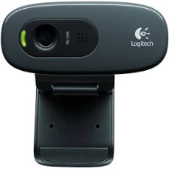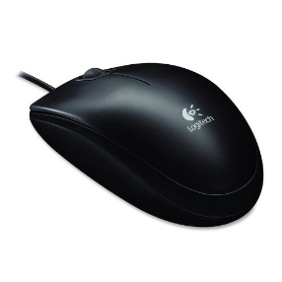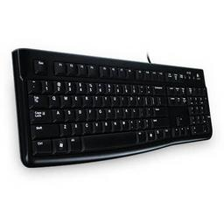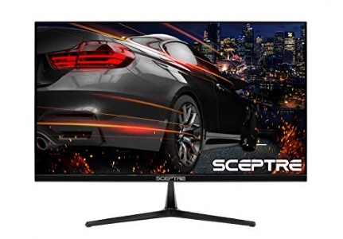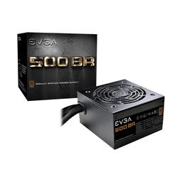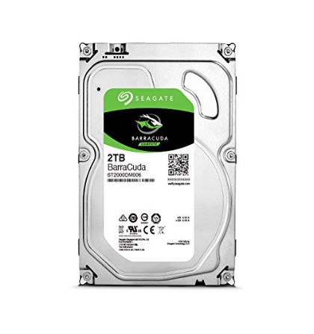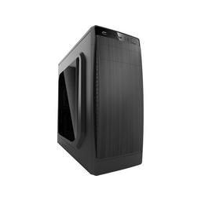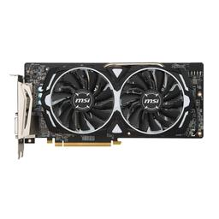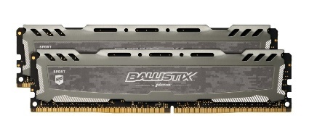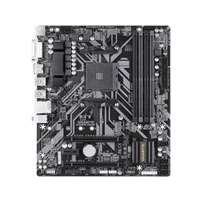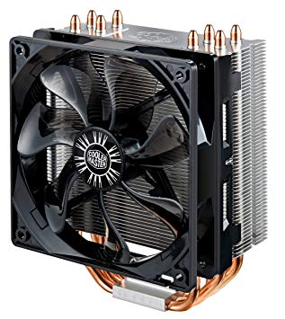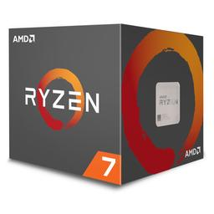

LOGITECH HD Webcam C270 £15.99

Logitech B100 Wired Optical Mouse £6.99

Logitech K120 Wired Standard Keyboard £8.99

2x Sceptre E255B-1658A 24.5" 1920x1080 165 Hz Monitor £164.99

HEC HX310 ATX Mid Tower Case £34.99

EVGA BR 500 W 80+ Bronze Certified ATX Power Supply £46.88

Seagate Barracuda 2 TB 3.5" 7200RPM Internal Hard Drive £85.87

MSI Radeon RX 580 8 GB ARMOR OC Video Card £159.99

Crucial Ballistix Sport LT 16 GB (2 x 8 GB) DDR4-3200 Memory

£74.99

Gigabyte B450M DS3H £72.89

cooler master hyper 212 evo **£28.00**

Ryzen 7 2700 £179.89